How to run a clothes swap
Clothes swapping is a great way to get a new wardrobe in a cheap and more sustainable way. This ‘How to’ is designed to give you a simple, step by step guide to running an event! Find out more about why reducing fashion and clothing waste is important at www.gloucestershirerecycles.com/fashion
You can borrow our clothes swap kit from Gloucester which includes hangers, signs, chalkboard, mirrors and clothing rails if you need them. Please fill in the Microsoft form online at Gloucestershire recycles.

Getting started
Where could I host a clothes swap?
- On your street, spread the word through your neighbourhood WhatsApp.
- At a lunch or party with your friends
- At your school fete or Christmas market
- At work, in your lunch hour or at a work event
Timeline
- At least 8 weeks ahead – start planning and assemble your team
- At least 7 weeks ahead - confirm your date and venue, complete your risk assessment and confirm your insurance details
- At least 6 weeks ahead – get your press release to local media outlets if needed, print off posters and start distributing them
- At least 4 weeks ahead – start marketing online, send out information to key players in your local community making it clear what you want from them and how they can get involved. Include 3 top bullet points with ‘things to do’ in your communications.
- At least 3 weeks ahead – Send out newsletters to be used on local mailing lists and Facebook groups.
- At least one week ahead – do daily social media posts, confirm the details with your venue and helpers and that they are all still able to attend.
- The night before – confirm the details and do your final marketing push!

To do list:
- Assemble a team, it is much easier than doing it on your own! Assign roles, for example, health and safety, marketing, location booking, equipment, decorations, clothing quality control, event helper, event leader.
- Decide on a location and time, consider when most people will be able to make it and if you have enough time to promote your event. Do you need to hire a venue or can you use a free space?
- Decide if you have a swap limit (for example do you want people to bring no more than 5-10 items so there aren’t lots leftover at the end).
- Decide what you will do with leftover items, do people need to take them away or will you organise to take them to a charity shop or clothes bank?
- Strat thinking about a risk assessment if it is a public event
- Do you need to get public liability insurance or will your venue cover you? Ensure you have relevant insurance.

What equipment will you need?
- Clothes rails
- Tables
- Hangers
- Shoe racks (optional)
- Changing area
- Mirrors
- Music
- Decorations (optional)
- An A-frame board to advertise your event on the day (optional)
How will your clothes swap work?
- Some events charge for entry to cover the costs of hall hire and organising and some are free - decide what is best for you. Some events are used as fundraisers for charity.
- Do you want to put a limit on the number of clothes to swap? If so how many?
- Will you use tokens or just trust people to pick up the same amount of items as they dropped off?
- Will you ask for clothes to be dropped in advance or will you receive them on the day?
- Specify the items need to be in good condition, you could also ask your local repair café to come along and help with any repairs at the same time as your swap.

Marketing
Now you have some ideas about how your swap will work you will need to start marketing it. There are lots of suggestions below and you can download poster templates from our website.
Word of mouth
Talking to people is the best way to advertise, talk to friends, family, colleagues and neighbours. Get them to tell their friends, family, colleagues and neighbours and spread the word! Get people to tell you whether they are able to come along so you know early if you will have some attendees.

Email/newsletter template
Would you like to refresh your wardrobe?
Come along to our clothes swap event on [date]…

The fashion industry accounts for about 8-10% of global carbon emissions, and nearly 20% of wastewater. And while the environmental impact of flying is now well known, fashion sucks up more energy than both aviation and shipping combined😦.

When a new pair of jeans is made, an estimated 16.2kg of CO2 is emitted – the equivalent of driving over 58 miles in a car! So, by recirculating our clothes – buying, wearing and donating second hand – we can help to reduce the demand for new clothes. And this could in turn help to reduce the damage to our planet.

When?
[date] Please drop your clothes off anytime from [time], but the ‘shop & swap’ drop-in event will run between [time]. It’s important that we have the items dropped off in advance so that we can set up ready for people to browse. 😊

Where?
[location including post code] [consider including a what 3 words if needed]

What?
This is a clothes swap event. You can bring along up to 5 items of clothing (shoes and accessories also accepted) but please ensure they are in good enough condition/quality that somebody else may want them! They must be washed and in good to excellent condition. All styles, shapes and sizes welcome!

Please note, this is not just a chance to donate clothes – whilst we will donate any leftover items to charity shops, you must come with the intention of swapping/taking different items away with you.

If you have any specific questions, please contact [email or phone number and name] 😊

We hope to see you there!

Social Media template (WhatsApp, Facebook, Nextdoor, X/Twitter, instagram)
Please see the social template below and download image at Gloucestershire recycles.


Do you have clothes that you would like to swap? Join us for our first XXX [name of street, school, community group] clothes swap on the [DATE] at [TIME]. [contact] for further details on [phone number or email address]. Find out more here [link to website or face book post].

Posters and flyers
Please see the poster template below and download at Gloucestershire recycles. 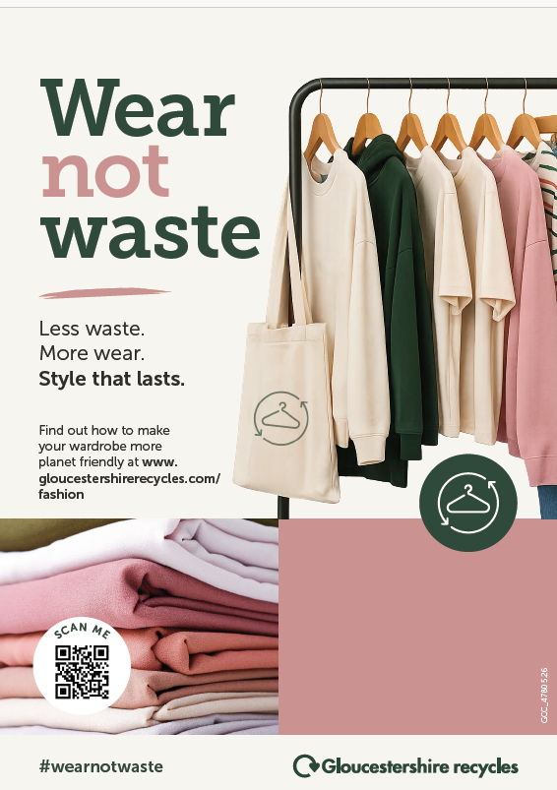

Put up as many posters as possible in your local area at least a month before the event. Ask local shops to put up posters, ask local residents to put posters in their windows. Your local community noticeboard may put up a copy of the poster for you.
Use A5 versions of your poster as flyers. Consider handing these out at schools, in your local library or putting them through local residents doors.

Press releases and local magazines
Send a press release to the local newspapers/radio approximately three weeks before the event. See the further resources section below for more details about how to write a press release.
If you have a parish magazine or newspaper include details of your swap in there. Have a look for ‘What’s On’ sections of your local newspapers and newsletters. Ask as many people as possible for ideas.

Banners
Banners can be cheap to print and if you have a good location to hang them. Make sure you measure where you are going to hand them and have a good supply of cable ties for hanging them up. Make sure you have permission to hang them.

Ensure you share the following information in all your marketing:
- Clothing must be in good condition i.e. not in need of repair, shrunk, stained, ripped, torn, missing buttons, sequins or beading, bobbly, discoloured or with broken zips.
- Specify if the swap is specifically for adults or children, whether you are focussing on men’s or women’s clothes etc.
- Specify if you will allow people to bring swimwear, shoes, underwear including tights/socks/leggings, nightwear, gym-wear and jewellery
- Who to contact for more information

Running the event
Suggested event timings
- 3 hours before – clothing drop-off – Items are checked in by the clothes swap team to check that they meet the clothes swapping criteria
- 30 mins before – Continue sorting / displaying clothes – Half an hour break between dropping off and the start of the clothes swap ensures that everything can be hung up / put out on display in time.
- Start time - The clothes swap opens! Time to swap! (the event could last anywhere between 2 – 4 hours depending on your venue, the availability of help and your preferences).
- Finishing time. Allow time to clear up depending on the size of your event.
- Drop off leftovers time. Plan who will drop any clothing left over off to charity shops or clothing banks, plan how to transfer these to the drop off locations.
Processing clothes
- Someone will need to look over the clothes as they arrive, are they in good enough condition to be swapped?
- Items can be rated according to their label/quality but this takes quite a lot of time and you may decide that isn’t necessary and that the most important thing is that items are in good, clean condition and ready to be worn again – not tired and past it!
- Don’t be afraid to refuse things that don’t meet the criteria and have a charity bag or recycling box ready for these.
- If you choose to use a rating system then think along the lines of: Gold – designer items and expensive High Street brands such as Whistles, All SaintsSilver – better quality High Street brands such as Reiss, Marks & Spencer, Zara Bronze – supermarket brands, Primark, New Look etc. If you are rating items you will also have to work out a system for labelling the item or create clothes rails specifically for those items.
- It is best to sort items by size and perhaps also by garment type (shirts, trousers, tops etc.)

Equipment you can borrow from Gloucestershire County Council:
- 2x clothing rails
- 200 x clothes hangers
- Mirror
- A-frame black board with chalk pens.
- 3 of each laminated signs (Tops, trousers, shirts, dresses, S, M, L)
- Textile repair leaflets

This guidance has been developed from the Bath and North Somerset guidance https://www.bathnes.gov.uk/sites/default/files/how_to_run_a_clothes_swap_banes_guidance_kit_0.pdf
Further resources
- Find advice from the Health and Safety executive on writing a risk assessment https://www.hse.gov.uk/event-safety/getting-started.htm
- Find a longer more complete guide to planning a community event here https://www.ticketsource.co.uk/blog/how-to-create-a-community-event
- How to get media coverage https://groups.friendsoftheearth.uk/resources/how-get-media-coverage
- How to write a press release https://www.theguardian.com/small-business-network/2014/jul/14/how-to-write-press-release

